CS 255 System Design Document Template

UML Diagrams

UML Use Case Diagram
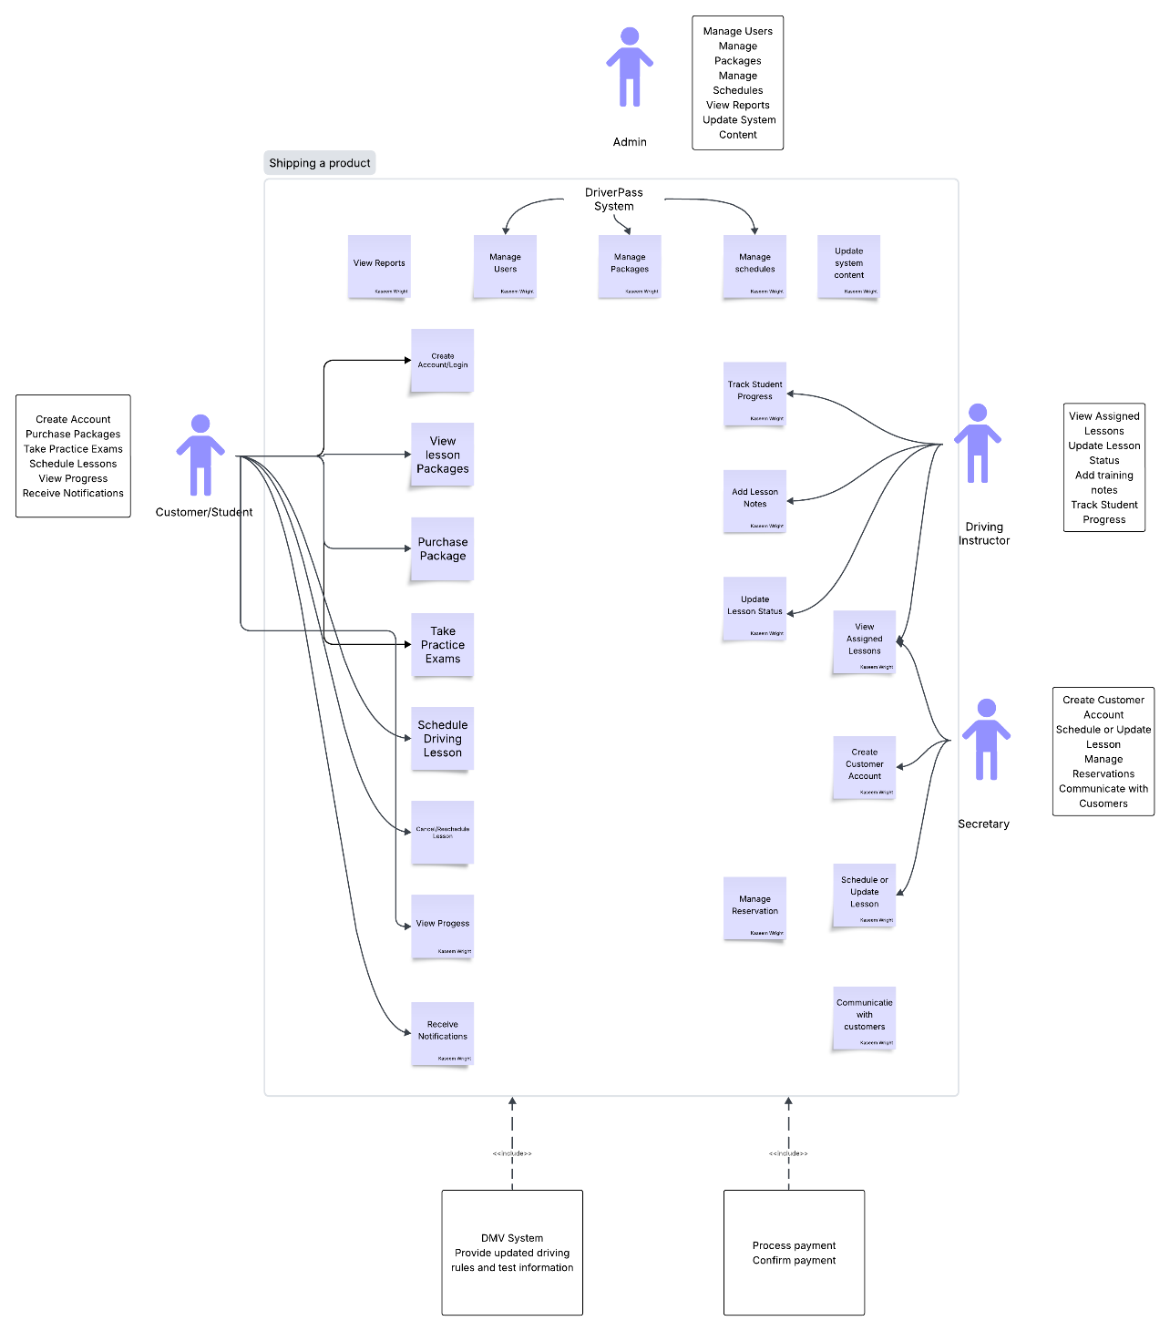

UML Activity Diagrams: Activity Diagram #1 and #2
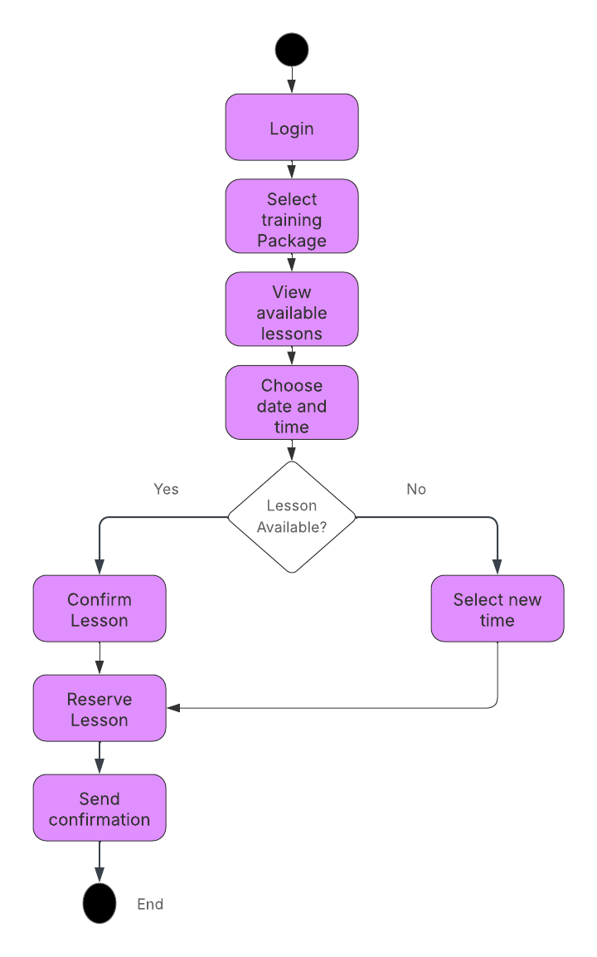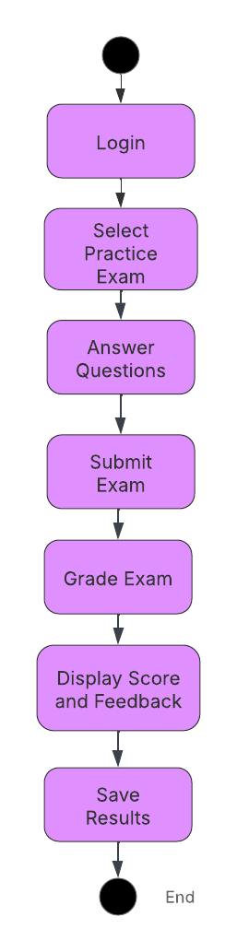

UML Sequence Diagram
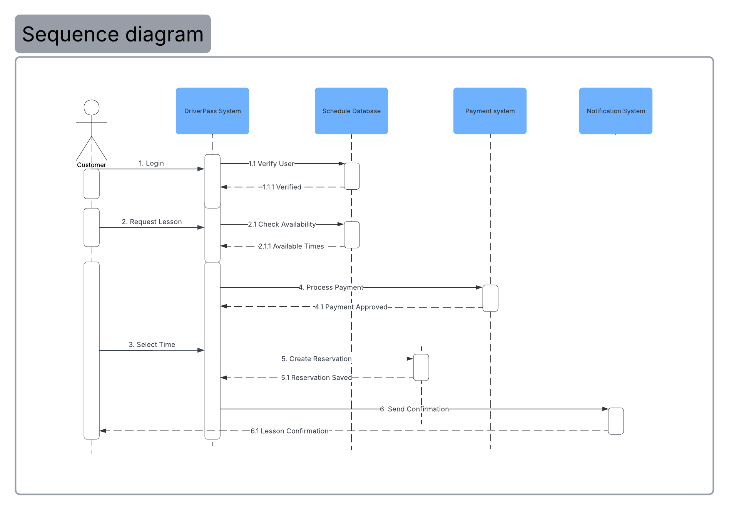

UML Class Diagram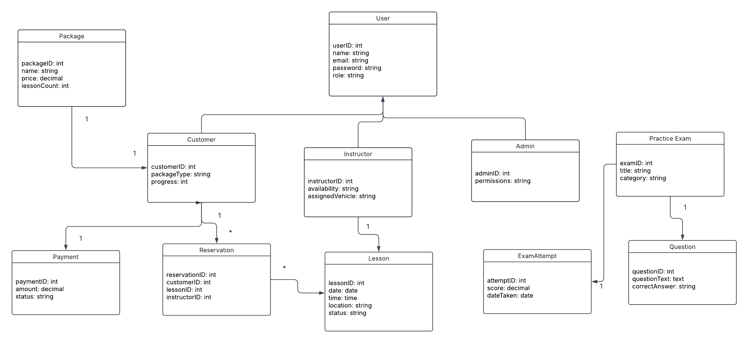

Technical Requirements
The DriverPass system will be a web-based application that is secure and can be accessible through desktop as well as mobile browsers. For the system to be able to manage customer accounts, lesson scheduling, practice exams, payment, and progress tracking will need a web server, database and cloud hosting. The system will be able to handle the role-based access needed for customers, instructors, administrators and management. And when it comes to security, it will have features such as password encryption, secure payment processing, HTTPS connections as well as regular data backups. For lesson confirmations and account updates, the system will use email and or text notifications.

